1. 0.18
2. 0.4
3. 0.52
4. 0.65
5. 0.533

$$P\left(Practice=true ⋀Healthy=true, Win=true\right)=$$

$$= P\left(Practice=true ⋀Healthy=true | Win=true\right)* P\left(Win=true\right) =$$

$=$ $0.8*0.7=0.56$

$$P\left(Practice=true ⋀Healthy=true, Win=false\right)=$$

$$= P\left(Practice=true ⋀Healthy=true | Win=false\right)* P\left(Win=false\right) =$$

$=$ $0.4*0.3=0.12$

$$P\left(Practice=true ⋀Healthy=true\right)=0.56+0.12=0.68$$

$P\left(Win=true | Practice=true ⋀Healthy=true\right)= \frac{0.56}{0.68}≈0.8235$

$P\left(Win=true | Practice=true ⋀Healthy=false\right)= \frac{0.12}{0.68}≈0.1765$

1. *Breeze: $¬{Breeze}_{1,1}, {Breeze}_{1,2},{Breeze}_{2,1},¬{Breeze}_{2,2}, {Breeze}_{3,2}$*

*Known: $¬{Pit}_{1,1},¬{Pit}_{1,2},{¬Pit}_{2,1},{Pit}_{2,2}$*

*Frontier: $\left\{{Pit}_{2,2}, {Pit}_{1,3}\right\}$*

*Other: other 3 pit variables.*

*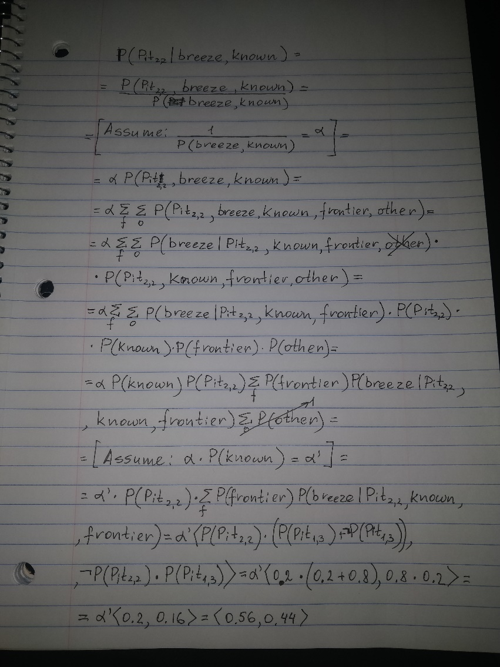*

1. This knowledge will not affect the probability because Pit in (3,3) is not in the frontier and it also gives breezes in the same place as the Pit in (2,2) will give. If we approach to the last phase of these transformations, if we assume that there is no Pit in (2,2), then we would still need to fulfil the requirement for having a Pit near (1,2). And the only place where we could put a fitting Pit is still in (1,3). So the transformations are not touched even though we added Pit in (3,3) to our “known” set and the calculation part is not changed either.